37.14: Multiplying the last equation of (37.21) by u and adding to the first to eliminate t
gives
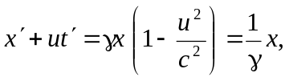
and multiplying the first by 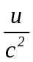 and adding to the last to eliminate x gives
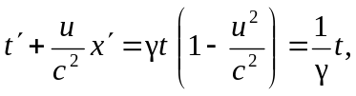
which is indeed the same as Eq. (37.21) with the primed coordinates replacing the unprimed, and a change of sign of u.

